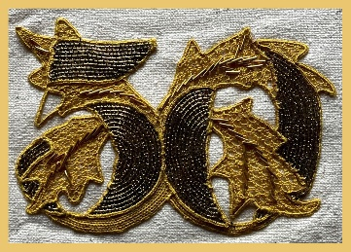
The Lace Guild’s Golden Anniversary Cape Project

While admiring the lace that has been made in the past, or maybe handling old bobbins on our pillows, we often wish that these items could speak and tell their story; how much we could learn about the people and their techniques if only they could talk! As the current custodians of the lacemaker’s skills we can amend that for future generations and pass down this knowledge with our golden cape project.

The Lace Guild would like to keep an archive of information about the lacemakers who participate. We would be grateful if you could complete the information below and send it in with your lace contribution.

Name:

Where do you live?

Please tell us a little about your own lace story.

Please tell us why you decided to participate in this project.

